

LA GRANDEE INTERNATIONAL COLLEGE
Simalchaur, Pokhara, Nepal

Lab Assignment
Of
“DSA (Data Structures & Algorithm)”
Submitted By Submitted To
Divya Sharma Ashwin Poudel
PU Registration no: 2025-1-53-0323
Semester: 3rd
Program: BCA

Q1. Program to implement stack using array
Algorithm:
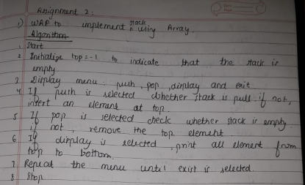Code:

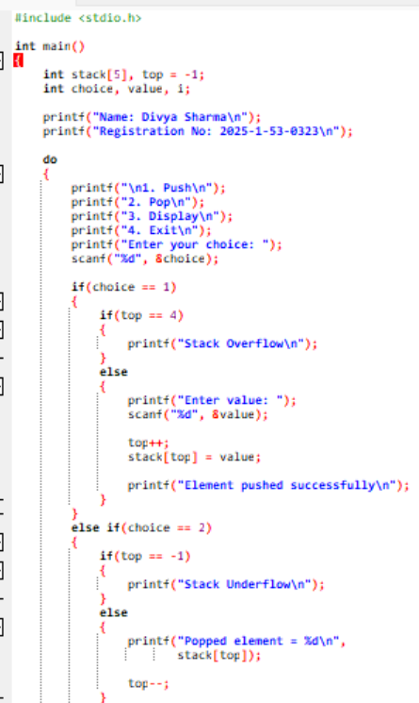

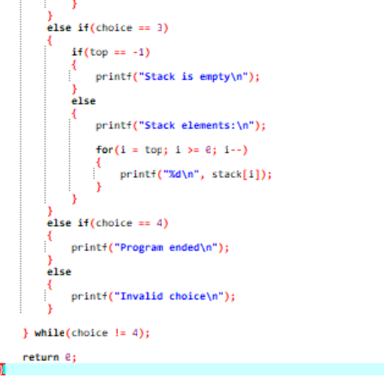

Output:

Result: The stack was successfully implemented using an array. The push, pop, and display operations were performed successfully.
• Time Complexity: Push and Pop – O(1); Display – O(n).
• Space Complexity: O(n), where (n) is the maximum size of the stack.
Q2. Program to calculate the factorial of a number using recursion
Algorithm:
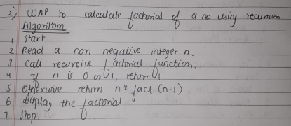
Code:
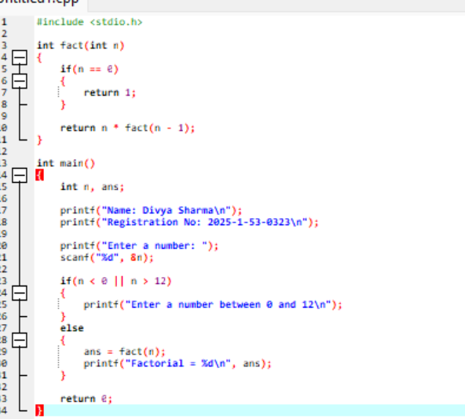
Output:
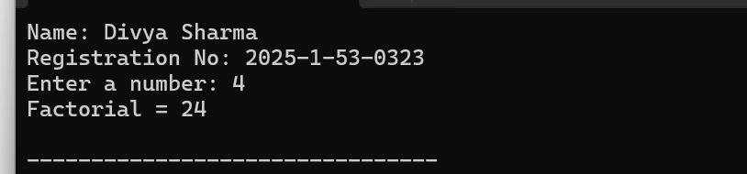

Result: The program successfully calculated the factorial of a given number using recursion.
Time complexity: O(n)
Space complexity: O(n), due to recursive function calls.

Q3. Program using recursion to find the GCD of two numbers. Algorithm:
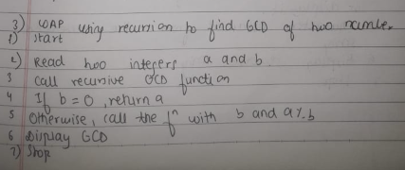

Code:
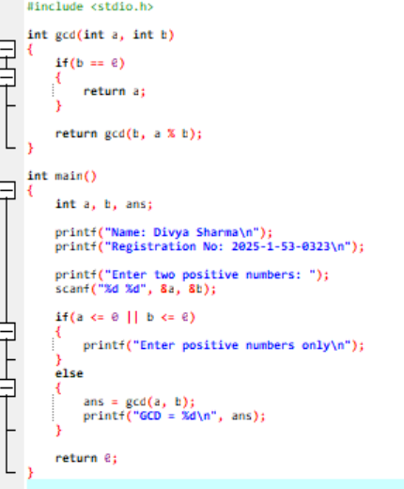

Output:
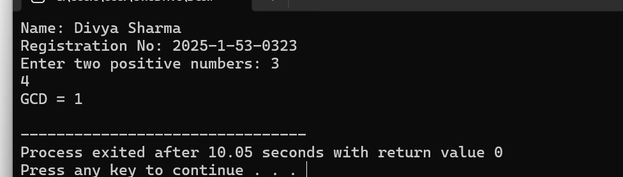
Result: The program successfully calculated the Greatest Common Divisor (GCD) of two numbers using the recursive Euclidean algorithm.
- Time complexity: O(log(min(a, b))) for positive inputs.
- Space complexity: O(log(min(a, b))) for positive inputs, due to recursive calls.
Q4. To find the power of 2 using recursion.
Algorithm:
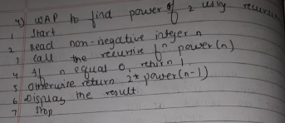
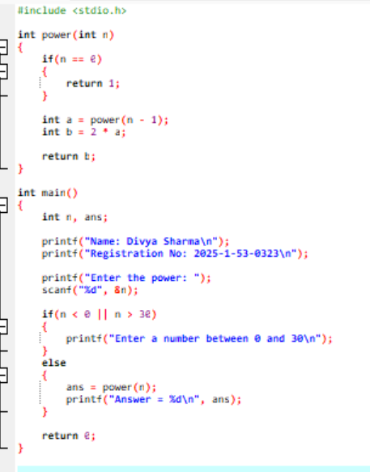
Code:

Output:
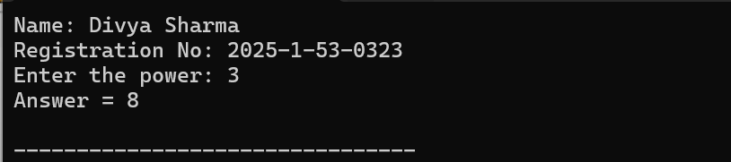
Result: The program successfully calculated the power of 2 using recursion.
- Time Complexity: O(n).
- Space Complexity: O(n), due to recursive function calls.
Q5. To implement Fibonacci series using recursion.
Algorithm:
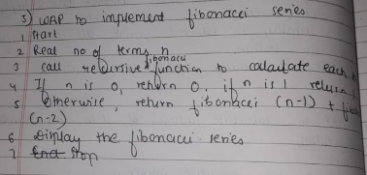

Code:
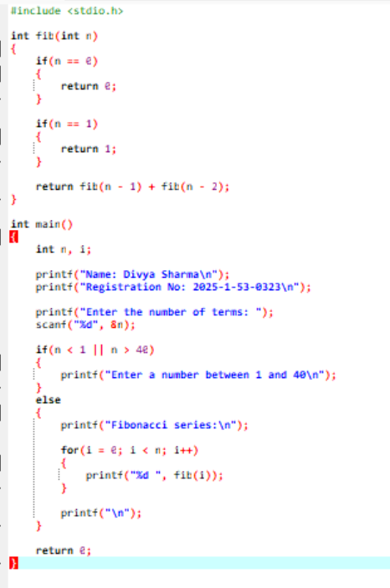

Output:
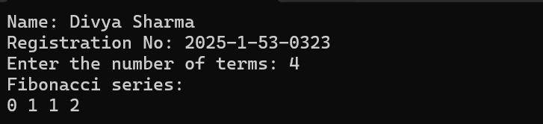
Result: The program successfully generated the Fibonacci series using recursion.
- Time Complexity: O(2^n) for the standard recursive Fibonacci function.
- Space Complexity: O(n), due to the maximum depth of recursive calls.
Q6. To reverse a string using stack.
Algorithm:
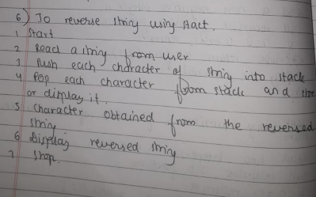

Code:
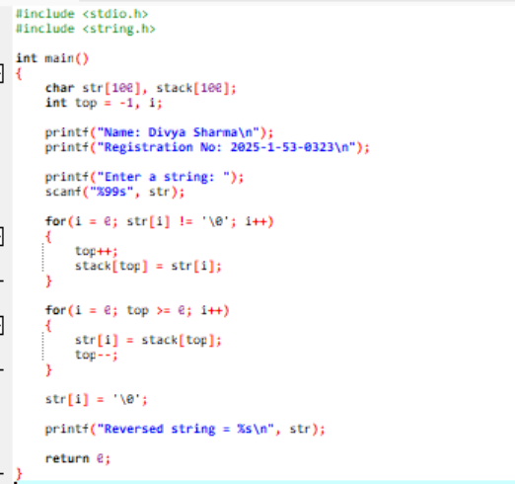
Output:
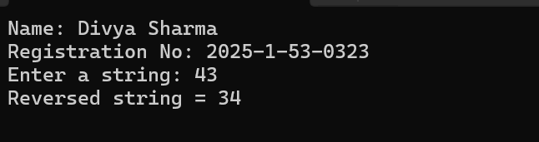
Result:
- Time Complexity: O(n), where n is the length of the string.
- Space Complexity: O(n), for storing the string and its characters in the stack.



